EZ-Phone User’s Manual

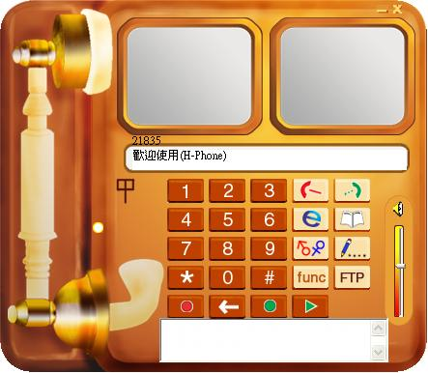
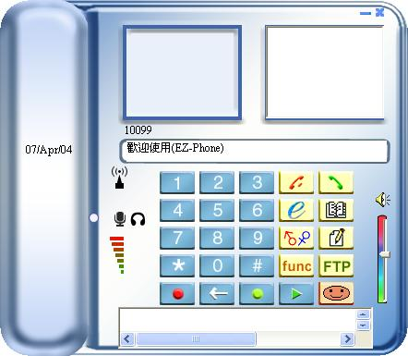

Copyright © 2003

System Requirement
1. Hardware：
CPU | Pentium III 450 MHz or above.
RAM | 64MB or larger.。
Hard disk | at least 5MB free space.
Network | LAN or MODEM

2. Operating System：
Make sure your Operating System is one of the Microsoft Windows 98SE/2000/Me/XP，Other operating systems are not supported by EZ-Phone。
Note：EZ-Phone do not support MS-Windows 95/98

支援服vic：

EZ-Phone User’s Guide
Installation
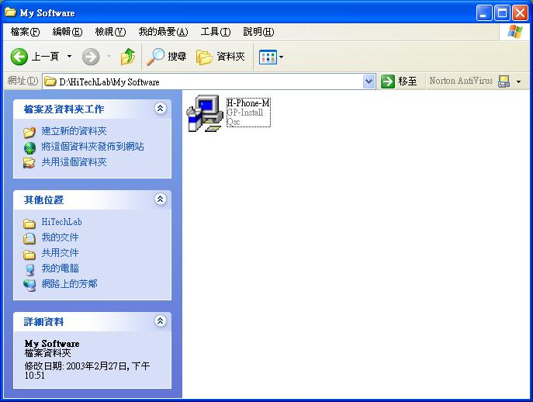
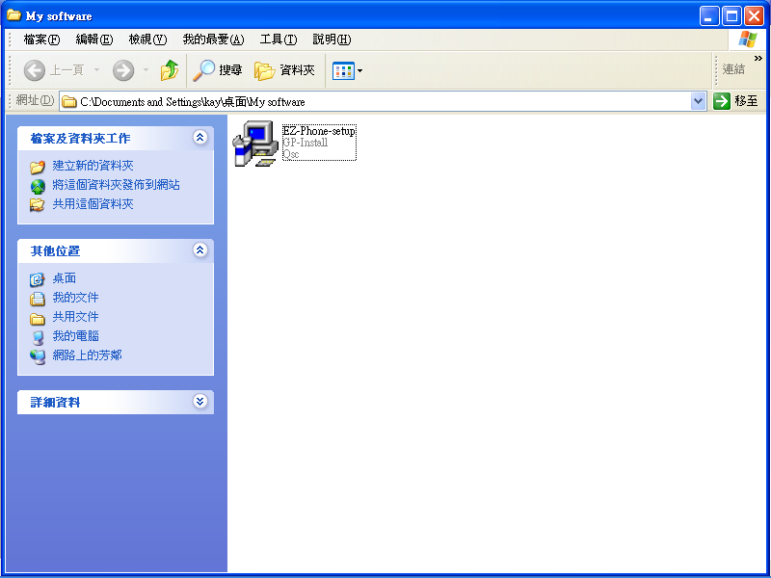
Double click the “EZ-Phone” icon; installation process will be starting immediately.

Click the “Next” button to continue the installation process.s wil
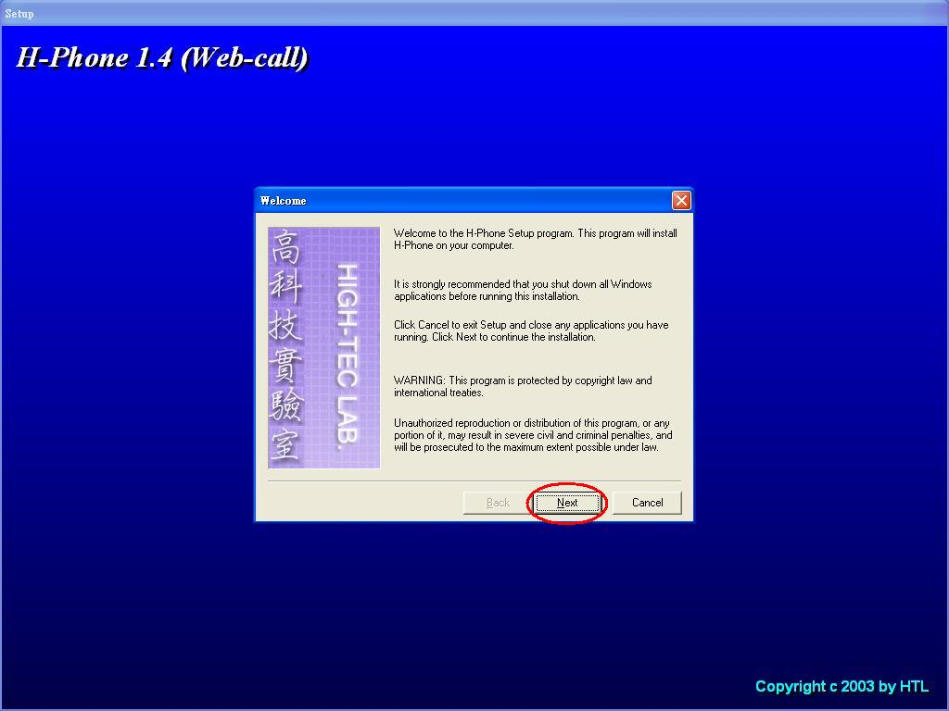
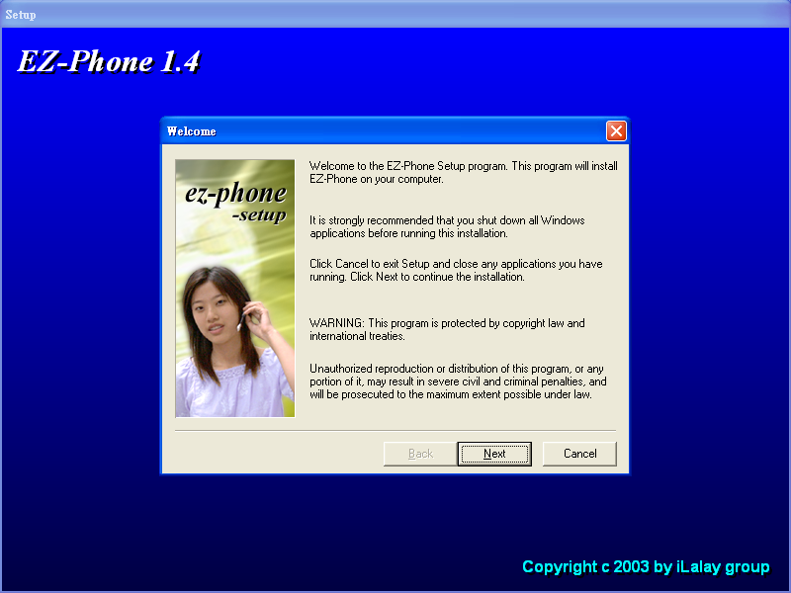
To execute the EZ-Phone, just double click the EZ-Phone icon on desktop.
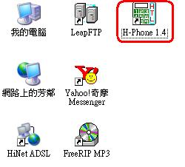
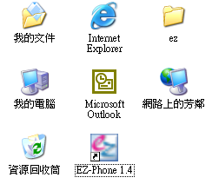
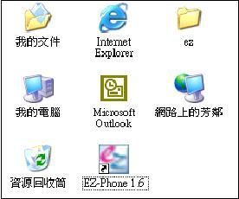
When EZ-Phone is running first time, users heed to fill out the basic information below. Theollowbelows。

Remove auto-starting function
EZ-Phone will execute automatically aftr booting by deadows system. If you want to remove this function, you can delete the short cut of EZ-Phone in Startup Folder below. The example shw
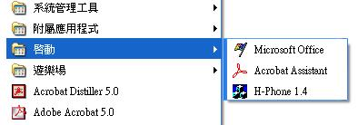
Delete刪除

EZ-Phone 1.6
Main functions of EZ-Phone

錄製主人問候語Recording Master’ voice message
聽取問候語Play master’s voice record
聽取留言Play the masterguest’s voice message
撥號數字區Number Zone Key Area
系統公告Announcement
音量調整Volume Control
掛斷Off
通訊錄Phone bBook
Textual 文字訊息Message Dialog
來電顯示/撥出電話Phone # Displaying Zone Area
檔案傳輸File transfer
最小化Minimize/隱藏Hide
接聽/撥號Dial
麥克風偵測MIC
Detect
網路訊號品質偵測NET DetectNetwork Quality Detect

Play the voice message

Backspace

Phone number displaying area: The main displaying area caller‘s phone nof thepgr

- area:e to click h使用鍵盤上面之數字鍵來輸入，皆可互
- Minimize/Hide button: Click to minimize EZ-Phone to taskbar. Click to hide EZ-Phone to system tray.
- Microphone signal detect: mdicate the system microphone is working when the ligh ot. 若
- Network quality detect：Display network quality is good or bad.類似行動電話訊號強弱的功
Introduction to main function buttons：

EZ-phone號碼後，l and of
Offliok
Recording master voice message.
Playing master voice message.
Playing the guest’s voice message.
Phone Book: ：Toadd or delete friend’s name and phone # 可用來新
Textual message nsmsog: Sending/Receiving tt with you您也可在與對方聊天
File transmission function: click the FTP button and select the file to starting point to point file transmission.
Main function setup: To set the user’s account and password.： 用以設使用
Match friends
’s wWe e link.宜站
Backspace

Dial
There are two ways to dial out:
1. Press phone numbers and the click the button to dial out.
2. Open Phone Book and then double-click thesome onn the Phone Book you want to dial out.
10119
10119
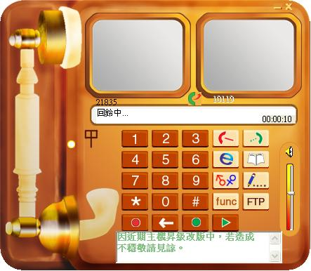
As figure shows above, the dial icon and phone number “10119” will appear after you dial out.

EZ-Phone also support the function of textual Message transmission.dialog. WWhen the users Ccick the ion icon , to text message transmission dialog will show as follows..
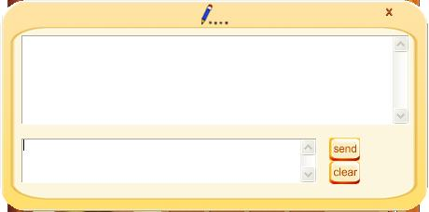
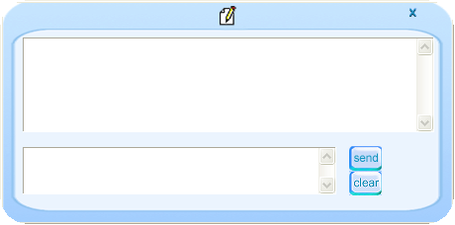
As the figure shows below, the upper window is use toof owing the conversation message, and while wer framewindow id to typeof typing tage whichfor you want to sender typing textual message, click the butto or typing enter key osend the message and click button to clear the all of th ontent of the uppeamew.如下圖所示，上面的方框用來顯示雙方交談的文字訊息，而下面的方框則用來輸入文字交談訊息。使用者輸入文字後，按可將訊息傳送給對方。而按則可用來清除上面的顯示框內的文字。
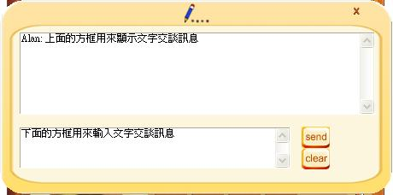
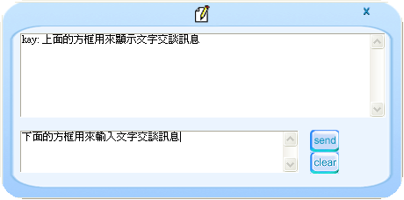

Phone Book
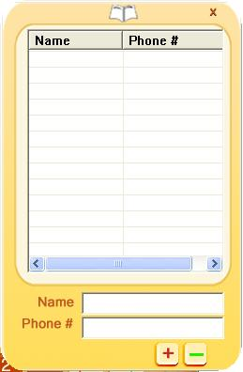
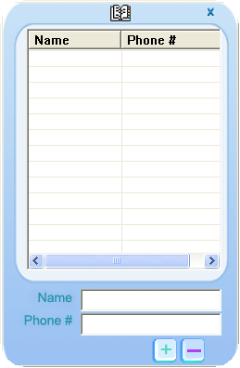
Using the built-in Phone Book function, users can easily make a phone call to friends. Just press the button, the Phone Book dialog box will show up as follows.

To add a friend to Phone Book, users must enter the friend’s Name and Phone # as the figure shows below.
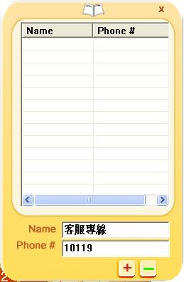
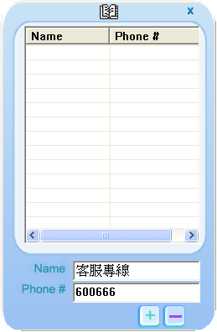

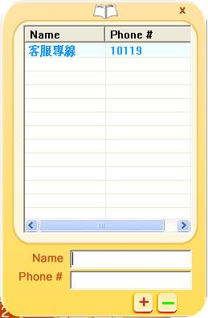
After entering friend’s name and phone #, press the button to add ihe new friend to the Phone Book.
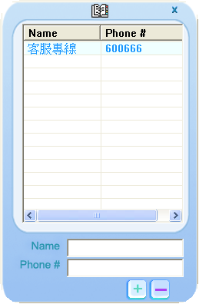

File Transmission
After pressing button , the file select dialog box will show up as felow.

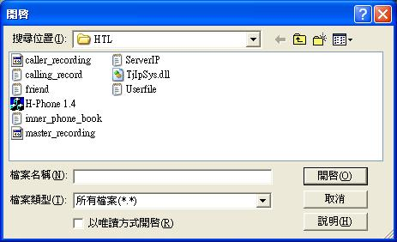
If the connection not established, the “Need to get a target before FTP” message will shows when button pressed.
- EZ-Phone does not support virtual IP to virtual IP file transfer function in version 1.5. It will be supported soon in next version.本程式目前尚不支援虛擬IP對虛擬IP之檔案傳輸功能

Terminate the EZ-Phone
EZ-Phone can early be quitted using two ways, one is moving your cursor to taskbar and then click right mouse button to press “Quit” button, the other is to press ESC key on keyboard.bar and click right mouse button at EZ-Phone icon, then press “Quit” to termi
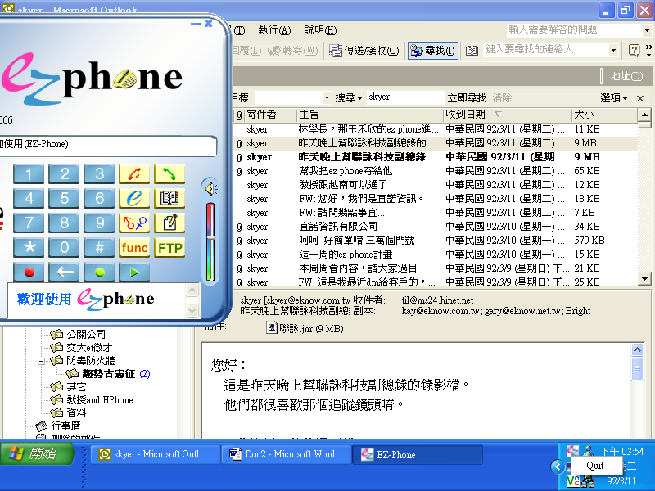
2.按此Quit鈕即結束執行Press Quit
1.先在此按滑鼠右鍵Click Right Mouse Button
錄製主人問候語
聽取問候語
Play voice messagee
Backspace
撥號數字區
Minimize/Hide
File transfer
來電顯示/撥出電話
Message
Phonebook
Off
Dial
Volume Control
Announcement
MIC
Detect
NET Detect

